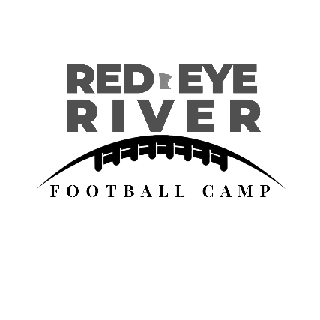

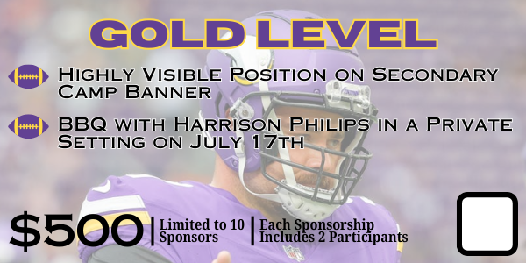
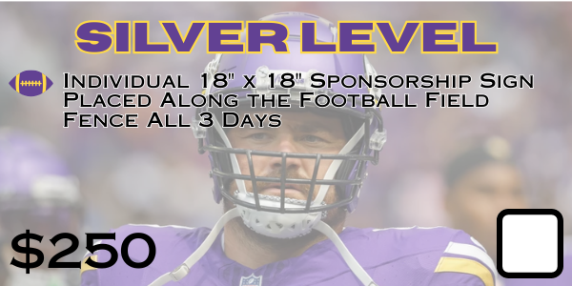
Red Eye River Football Camp is hosting our 5th annual youth football camp from July 15th to 18th in Menahga and Sebeka. This Camp brings together children in grades K-6 from across Minnesota, offering them the chance to develop self-esteem, engage in physical activity, and learn the basics of football. In the past we have welcomed Vikings Legends Chuck Foreman, Teddy Brown, and John Randle as well as current NFL Star KJ Osborn. This year, we are thrilled to have Vikings captain and defensive tackle, Harrison Phillips, as our celebrity coach.
To ensure that every child can participate, and to keep camp free, we rely on the support of local businesses like yours. We kindly request a contribution, which will go directly towards providing jerseys for the children, snacks, and securing the appearance of our celebrity coach. We rely entirely on volunteers and donations, and 100% of the money received goes directly into the camp. Your sponsorship at at the Platinum or Gold level will also give you and a guest the opportunity to golf or BBQ directly with Harrison Phillips.
Your partnership will make a tangible impact on the lives of these young athletes. It will help create a sense of unity and pride as each child receives their own camp jersey. Your donation will also help grow football in our area, as we have kids signed up from Bertha, Hewitt, Clarissa, Eagle Bend, Perham, Frazee, New York Mills, Park Rapdis, Nevis, Menahga, Sebeka, Verndale, and more. Additionally, your support will enable us to accommodate the growing demand, as we anticipate up to 300 participants this year.
We genuinely appreciate your consideration of this partnership opportunity. By joining together, we can make a lasting difference for these children and demonstrate your commitment to our community. If you have any questions or need further information, please feel free to reach out to us.
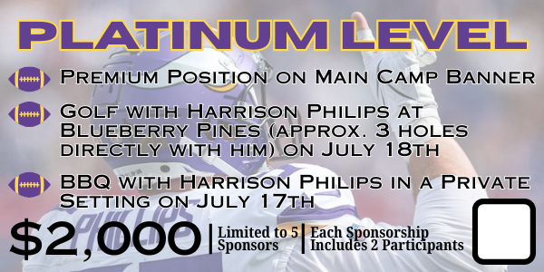
Thank you for your time and ongoing support. We look forward to the possibility of collaborating with you and making this year’s football camp a resounding success!
Warm Regards,
Kim Rife
Red Eye River Football Camp Coordinator
740-304-2996
rifesllc@hotmail.com
Please mail checks and forms by July 3rd to:
Red Eye River Football
PO Box 111
Park Rapids, MN 56470

